Holy Rosary School

Kewaunee, WI

Kindergarten Supply List

1 large, sturdy book bag

1 bottle of Elmer’s School glue

2 boxes of Crayola crayons (24 count)

5 pencils

1 folder

1 Fiskars scissors

2 packages of Crayola markers (Classic colors)

1 set of watercolor paints

5 glue sticks

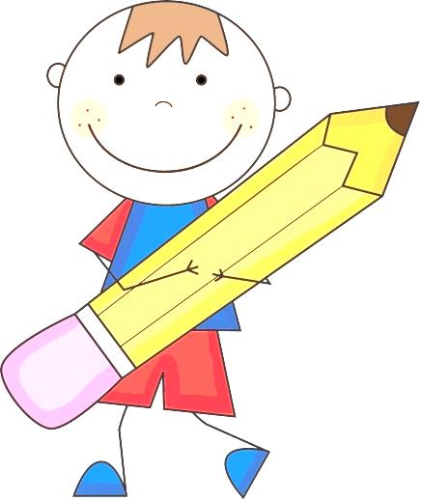1 set of headphones (no earbuds)

1 box of Kleenex

1 box of Ziploc bags (gallon or quart size)

1 ice cream bucket (no lid – to hold supplies)

2 boxes of graham crackers or snack crackers

1 beach towel to use as a resting mat

1 package of napkins or 1 roll of paper toweling

Change of clothing to keep at school

Tennis shoes for Phy. Ed. class